Case Study 3 - Place Pulse data to study perceived safety and greenery in London

David Buil-Gil and Reka Solymosi

Place Pulse was an online crowdsourcing project designed to record data about perceptions of safety, beauty, wealth, liveability, boredom and depression in areas of 56 cities from 28 countries. It was created by Philip Salesses, César A. Hidalgo and others at the Massachusetts Institute of Technology in 2010 (Salesses et al., 2013), and in total it recorded more than 1.5 million votes across nine years. Participants were presented with two images selected randomly from Google Street View, and asked, for example, “Which place looks safer?” to measure perceptions of safety (see Figure 1), or “Which please looks wealthier?” to measure perceived wealth in urban areas. Participants did not receive any further information about the city or country of each picture, and thus they could only assess the visual elements of each image before selecting one or another, or clicking on ‘equal’. While the Place Pulse platform closed in late 2019, we were given access to all data recorded and requested permission make the data open access through an online repository (<https://figshare.com/articles/dataset/Place_Pulse/11859993>).

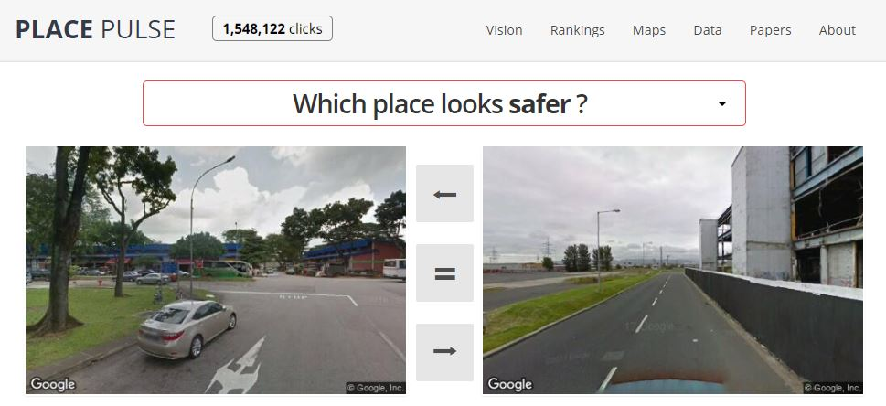

*Figure 1. Place Pulse website*

Data recorded in Place Pulse was used to estimate perceptions of safety in New York and compare these with known crime data recorded by the police (Salesses et al., 2013). Similar studies were conducted in Atlanta and other places (Buil-Gil and Solymosi, 2021). These data also were used to analyse the relationship between greenery and perceived safety. Li et al. (2015) analysed the visual cues of vegetation in images and the rates of perceived safety given by participants. They observed that the visibility of vegetation higher than 2.5 meters was significantly associated with perceived safety, while the vegetation below 2.5 meters had no statistical association with safety perceptions in most types of land use.

Another way to use the Place Pulse dataset to study the relationship between perceived safety and greenery is to calculate the average score of safety in geographic areas, and analyse if areas with larger mean values of perceived safety tend to be characterised by more vegetation than those with lower scores. In this case study, we have selected all votes of safety in London (i.e., more than 24,500 responses) and computed the proportion of ‘safer’ responses in areas defined by uniform hexagons. Each hexagon measures 350 meters across. In total, there are 15,041 hexagons in London, and we have responses of perceived safety recorded in 1,894 of them. Then, we can compare our values of perceived safety with the vegetation cover scores produced by Breadboard Labs and Greater London Authority (<https://data.london.gov.uk/dataset/curio-canopy>). As can be seen in Figure 2, there is a statistically significant, but weak, bivariate correlation between areas with more vegetation and those with higher values of perceived safety. More specifically, we see that the Spearman’s rank correlation coefficient is 0.13 (p-value<0.001) when we analyse all hexagons and 0.16 (p-value<0.001) if we study those areas with ten votes or more. All data and codes used to calculate this are available from Github (<https://github.com/davidbuilgil/safety-trees>). We have not analysed here if this association is driven by other variables which may be related to both the greenery and perceived safety, such as the level of deprivation or architecture of areas.

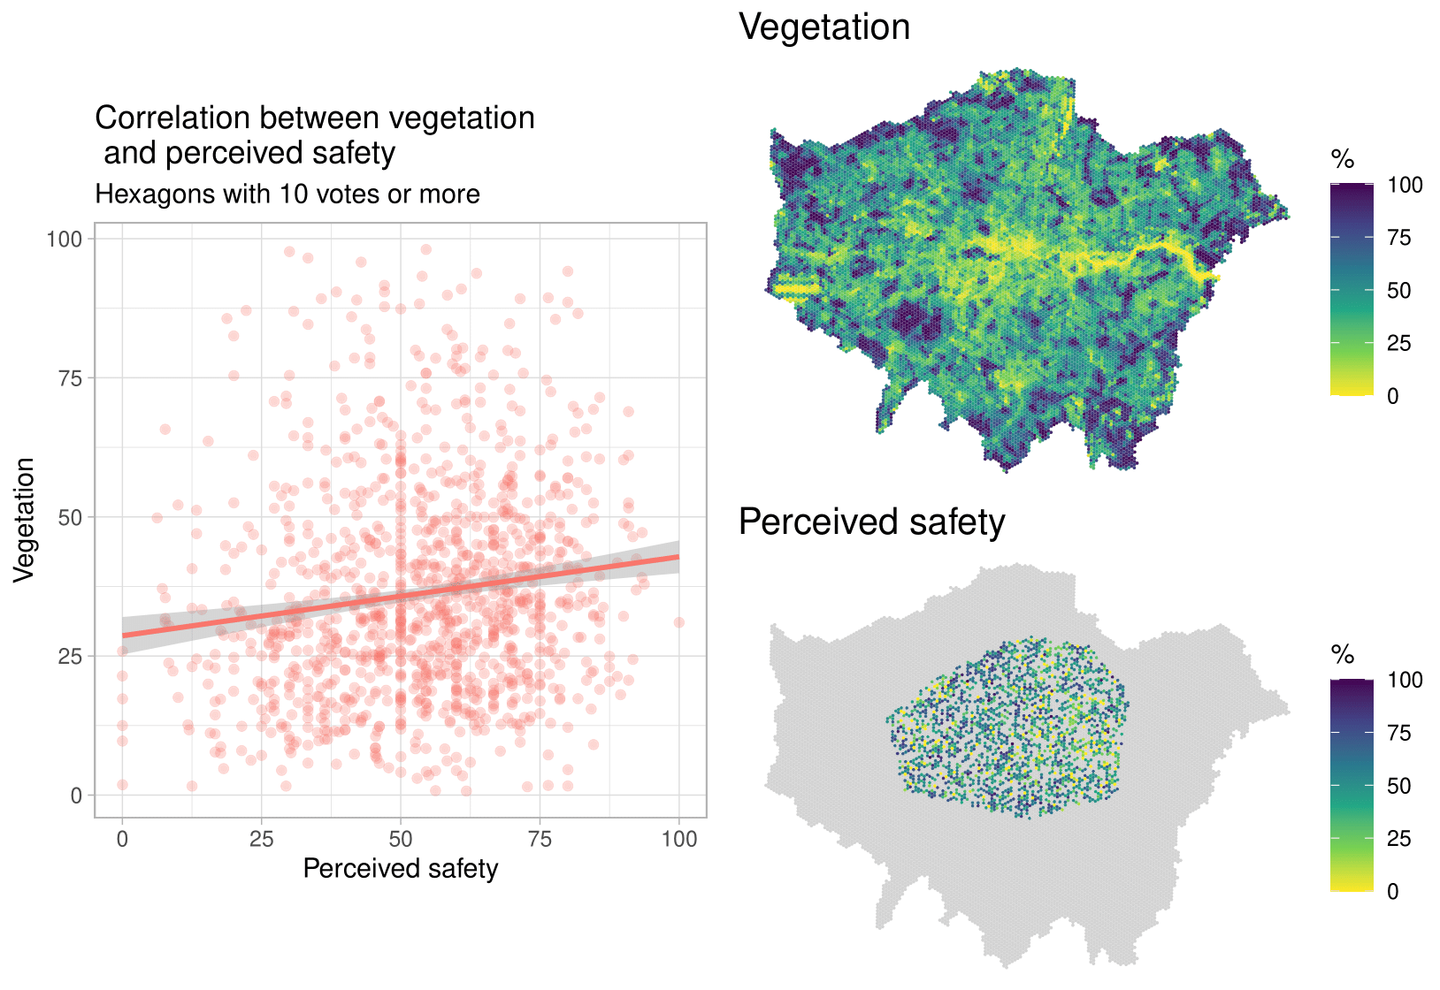

*Figure 2. Maps and correlation of vegetation cover and perceived safety*

It is important to note, however, that alike most crowdsourcing platforms, the Place Pulse data may be affected by a series of measurement issues that need to be considered when using these data. For instance, Salesses et al. (2013) noted that the majority of participants were males and young, and Buil-Gil and Solymosi (2021) reported that a small proportion of participants was responsible for large volumes of votes, and participation decreased over time.

**References**

Buil-Gil, D., and Solymosi, R. (2021). Using Crowdsourced Data to Study Crime and Place. In E. Groff and C. Haberman (Eds.), *The Study of Crime and Place: A Methods Handbook*. Philadelphia: Temple University Press.

Li, X., Zhang, C., and Li, W. (2015). Does the Visibility of Greenery Increase Perceived Safety in Urban Areas? Evidence from the Place Pulse 1.0 Dataset*. ISPRS International Journal of Geo-Information, 4*(3), 1166-1183. <https://doi.org/10.3390/ijgi4031166>

Salesses, P., Schechtner, K., and Hidalgo, C. A. (2013). The Collaborative Image of the City: Mapping the Inequality of Urban Perception. *PloS One, 8*(7), e0119352. <https://doi.org/10.1371/journal.pone.0068400>